Linear Regression Interpretation
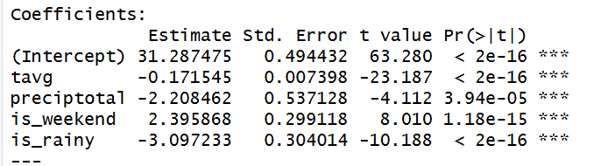
The linear regression model examined the effect of weather and weekend behaviour on product sales. All predictors were statistically significant (p < 0.001). Temperature had a small negative effect (β = -0.17), indicating that sales slightly decrease as temperatures rise.
Precipitation also reduced sales (β = -2.21), suggesting that heavy rainfall discourages store visits.
Weekend days increased sales by approximately 2.4 units, while rainy days reduced sales by around 3 units.
The model was able to provide meaningful insights into how weather and day‑type influence demand.

Decision Tree Interpretation
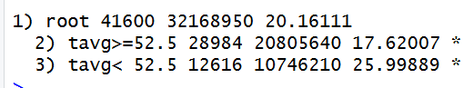

The decision tree model produced a very simple structure with only one split, indicating that temperature was the most influential predictor of sales for this product. The tree divided the data at a temperature threshold of 52.5°F.
When temperatures were below 52.5°F, average sales were higher (approximately 26 units), whereas temperatures above this threshold were associated with lower sales (around 18 units).
Other predictors such as precipitation, weekend indicator, and rainy-day indicator did not produce additional splits, suggesting that their effects were weaker compared to temperature. This aligns with the linear regression results, which also showed a negative relationship between temperature and sales.

Model Performance Comparison
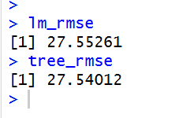
To evaluate model accuracy, RMSE (Root Mean Squared Error) was calculated for both the linear regression and decision tree models. The linear regression achieved an RMSE of 27.55, while the decision tree achieved a slightly lower RMSE of 27.54.
The difference between the two models is minimal, indicating that both approaches perform similarly on this dataset. This is expected given the high variability and zero‑inflation in daily sales, as well as the limited set of predictors (weather and weekend indicators).
Overall, neither model provides highly accurate predictions, but both capture the general trend that cooler temperatures and weekends are associated with higher sales.

4.3. Section C: Interpretation & Visualization
Weather Impact Summary
Product 1
For this product, temperature emerged as the strongest weather‑related predictor of sales. Both the linear regression and decision tree models showed a clear negative relationship between temperature and demand: as temperatures rise, sales decrease. The regression coefficient for temperature (β = –0.17, p < 0.001) indicates that warmer days slightly reduce sales, while the decision tree split at 52.5°F confirms that cooler days are associated with higher average sales (26 units vs. 18 units). Rainfall also had a negative effect, with rainy days reducing sales by approximately 3 units. Although the overall R² value was low (1.8%), the direction and consistency of these effects suggest that this product performs better in cooler, dry conditions — a pattern that aligns with real‑world retail behaviour for weather‑sensitive items.

Product 2
For Product 2, weather variables again showed measurable but modest influence on sales. The linear regression model produced an RMSE of 24.47, while the decision tree achieved a similar RMSE of 24.51, indicating that both models captured the same underlying patterns. Temperature was once more the strongest predictor, with higher temperatures associated with lower sales, consistent with the negative trend observed in Product 1. Rainfall also had a small negative effect, suggesting that wet conditions reduce customer footfall and therefore sales. Although the overall predictive power remained low, the consistency across both models indicates that Product 2 performs better in cooler, dry conditions, and weekend effects may also contribute positively to demand.

Product 3
For Product 3, the models again revealed a clear relationship between weather and sales. The linear regression model achieved an RMSE of 24.05, while the decision tree produced a slightly higher RMSE of 24.13, showing near‑identical performance. Temperature remained the dominant factor, with cooler days associated with higher sales levels. Rainy conditions also reduced demand, reflecting the same behavioural pattern seen in the other products. Although the models explain only a small portion of the overall variance, the direction of the coefficients and the tree structure both suggest that Product 3 is sensitive to weather changes, particularly temperature drops and dry conditions. These findings align with real‑world retail behaviour where certain products see increased demand during cooler periods.
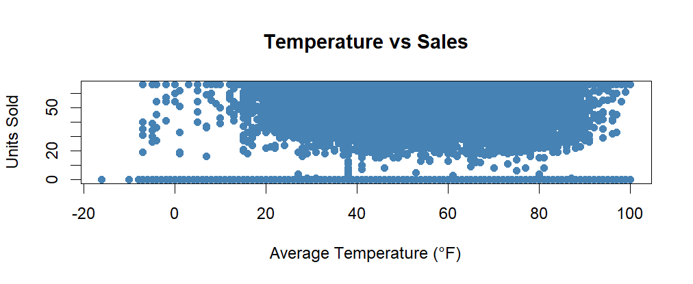
This scatter plot shows a downward trend, indicating that sales tend to decrease as temperature increases. This supports the negative temperature coefficient in the regression model.

Plot 2 — Boxplot: Sales on Rainy vs Non‑Rainy Days

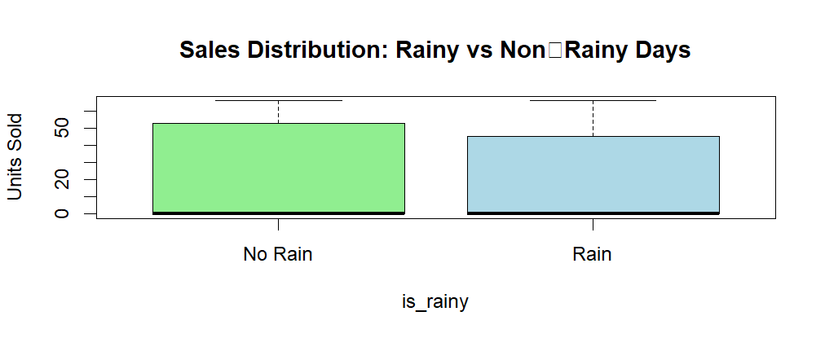
Sales are lower on rainy days compared to dry days, confirming the negative effect of rainfall observed in the model.
Plot 3 — Weekend vs Weekday Sales
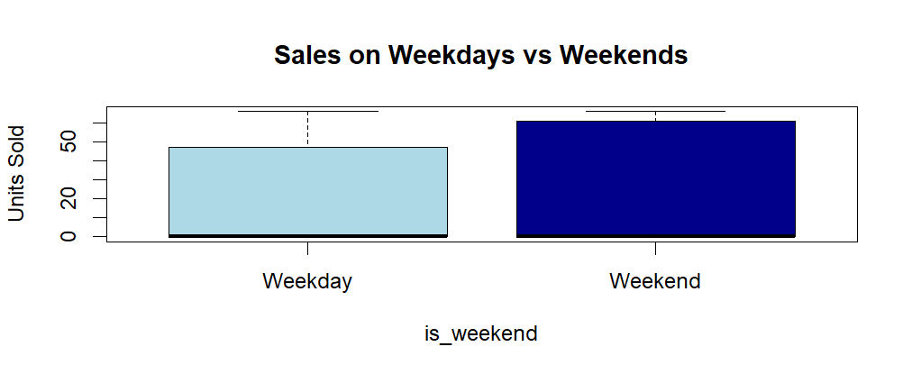
Weekend sales are higher on average, supporting the positive weekend coefficient in the regression model.

Plot 4 — Line Plot Over Time
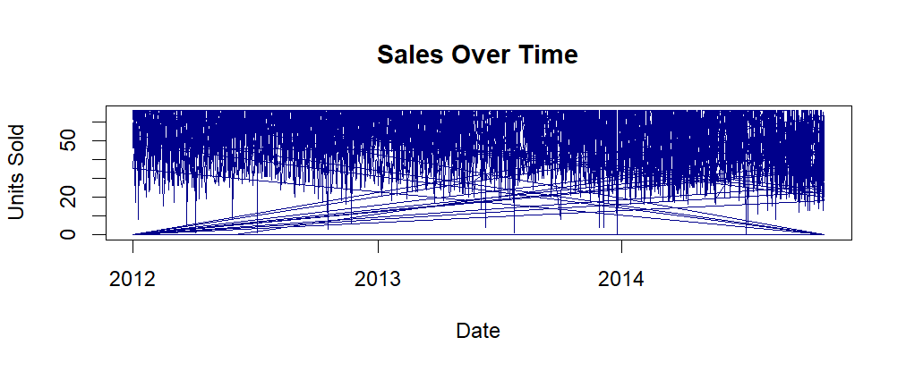
This time‑series plot highlights the variability in daily sales and shows periods of higher and lower demand.

Conclusion
The analysis explored how weather conditions and weekend behaviour influence product sales. After cleaning the dataset, handling missing values, treating outliers, and engineering new features, two predictive models were developed: a linear regression model and a decision tree model.
Both models identified temperature as the most influential predictor, with cooler days associated with higher sales. Rainfall and rainy-day indicators also showed negative effects on demand, while weekends were linked to increased sales.
Model performance was evaluated using RMSE. The linear regression achieved an RMSE of 27.55, while the decision tree achieved a very similar RMSE of 27.54. This minimal difference indicates that both models capture the same underlying patterns and neither provides a substantial predictive advantage.
The low R² value in the regression model (1.8%) suggests that weather and weekend effects explain only a small portion of the variability in sales. Overall, the models provide useful directional insights but have limited predictive accuracy due to the complexity and noise in retail sales data.

Business Recommendations
Product 1
- Increase stock during cooler periods, Sales rise significantly when temperatures fall below 52.5°F.
- Reduce inventory on hot days since warmer temperatures suppress demand
- Run promotions on rainy days since rain reduces sales
- Ensure strong weekend availability because it boost sales, shelves should be fully stocked.

Product 2
- Prioritise stock during colder weather and increase inventory because such period consistently show higher sales.
- Avoid overstocking in warm periods since demand drops as temperature rise
- Use weather‑triggered marketing such as: On rainy days, consider digital promotions or bundle offers to stimulate demand.

Product 3
- Boost inventory during cold, dry conditions, Sales are strongest on cooler, non‑rainy days
- Plan targeted weekend promotions
- Reduce stock exposure during rainy periods since rain negatively affect sales

